



HOW TO GUIDE:
SPAMTITAN

SPAMTITAN:

- SpamTitan only tracks Sent and Received emails from External
(Out of the Organization) Users.
- Spam Titan only keeps emails for 21 Days.
- Banned Attachment emails can only be released by Domain Administrator or Global Admin.
- Users are not set to release any Banned Attachment emails as most viruses gets sent through zip files.
- Users will only be able to release email that picked up as Spam.

- Log in to “SpamTitan” – see “Dashboard”:

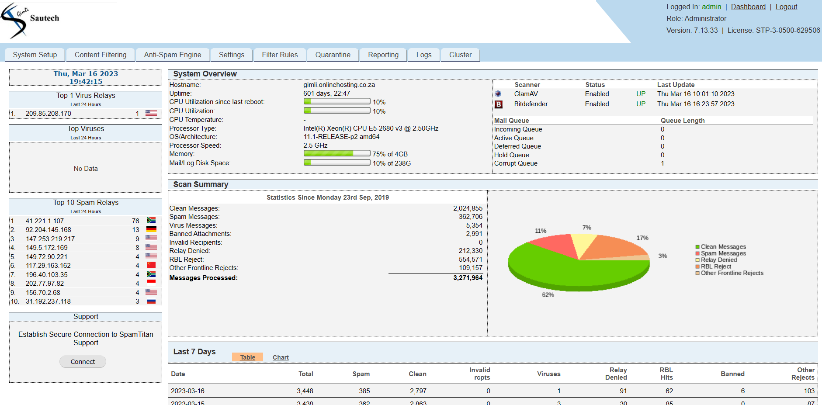

Once the Domain is loaded:
- Go to “Anti-Spam Engine
- Click on “Domain Policies”
- Select “Domain”
- Click on “Edit”:

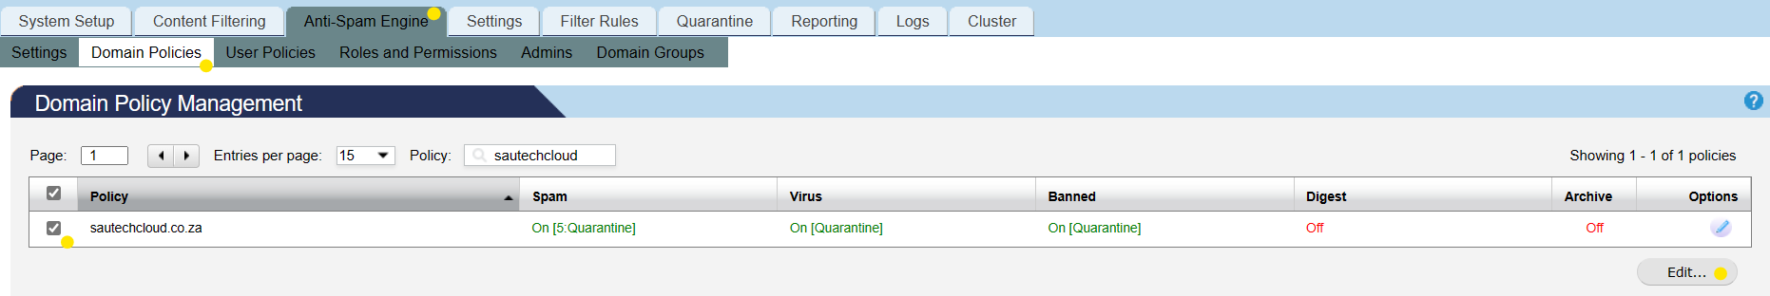

- Set overall “Domain Spam Score”
- Ensure that “Domain Archive” in on, all clean messages received by this Domain are stored in History

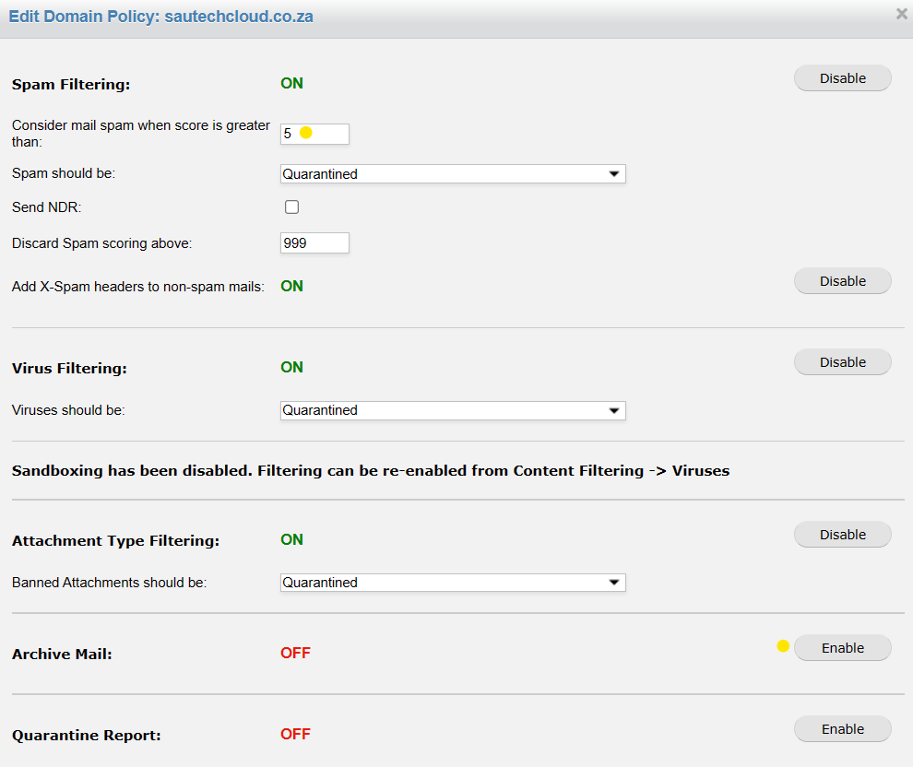

Domain Administrator:
- Domain Administrators can be assigned to manage individual Domains on the SpamTitan Gateway.
- A Domain Administrator can view the quarantine for their Domain, generate reports and view mail history.
- A domain can have multiple administrators.
- Click on “Apply”:

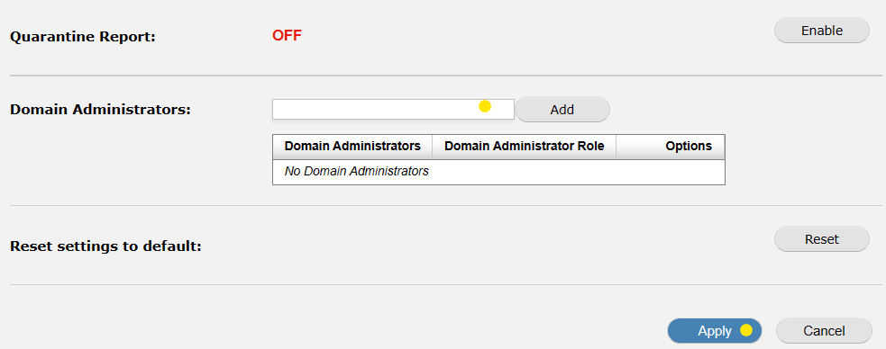

- To Load Users:

- Go to “Anti-Spam Engine”
- Click on “User Policies”:

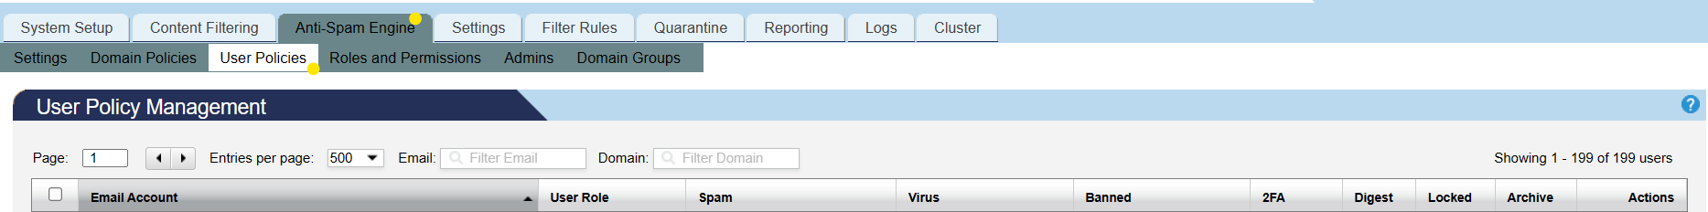

- Add “Users”

Complete the following Information:
- Email Address
- Add “Spam Score”
(Higher Score – more lenient towards incoming mail;
Lower Score – stricter towards incoming mail)

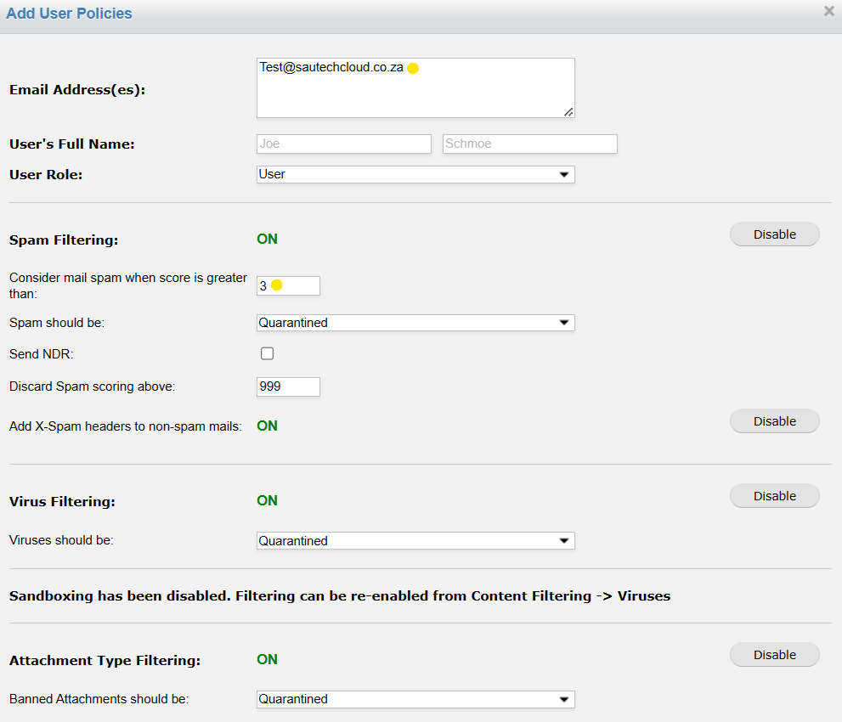

Enable:
- Archive Mail
- Lock Policy: if enabled, any Domain policy change will not affect this user policy.
- Quarantine Report: A Quarantine report is generated for this user should they have messages in Quarantine.
(a Quarantine Report can only be sent once a day)
- Click on ”Add”:

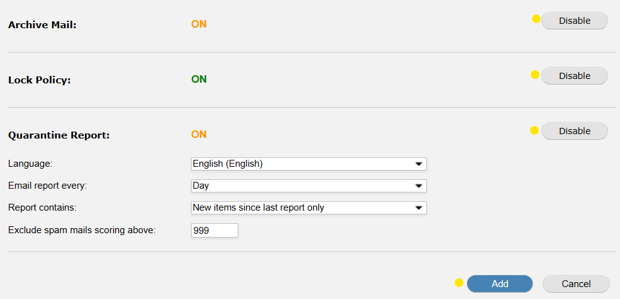

- Content Filtering:

- SpamTitan blocks the below Extension Filters attached in an email:
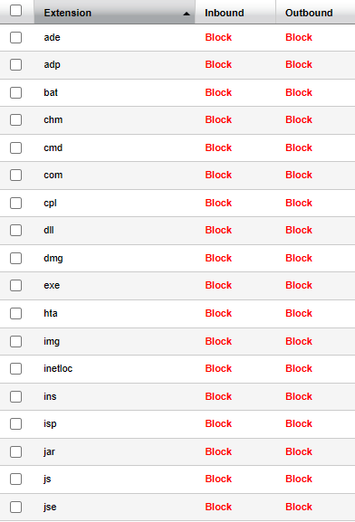
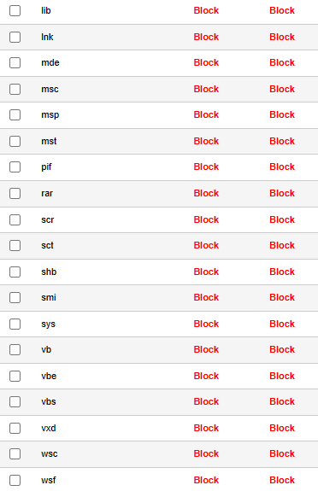

- To Whitelist an email address which usually picks up as a “Banned Attachment” go to “Content Filtering:”

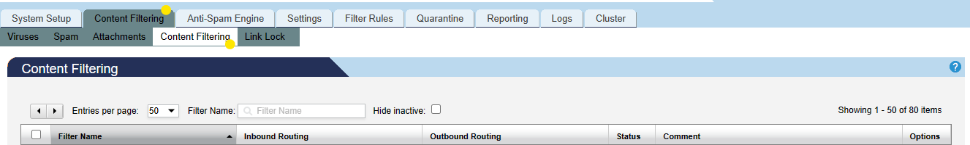

- Click on “Add”

Complete the following Information:
- Filter Name
- “Value”: email address preferred to be whitelisted
- Tick the box for “Apply to Headers”
- In “Description Box”; type in: “From:”
- “Inbound Action”: Select from the “Drop Down” – “Allow”
- A “Client Name” may be added in the “Comment” section, but, not necessary:

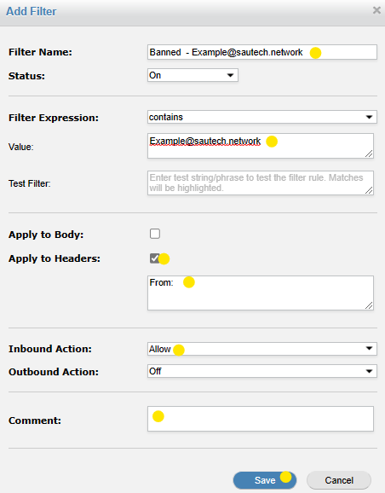

- Filter Rules:

- Where an email address or Domain can be added to the Global Blacklist or Global Whitelist:

- The email address/Domain will the blocked or whitelisted for the entire SpamTitan. This is for emails, picked up as “Spam”

- Releasing “Banned Attachments/Spam”:

- Click on “Quarantine” tab
- Select “Message Quarantine”
- Complete either: “Recipient” or “Senders” email address
- Select “Date Range” (on the right)
- Click on “Apply”
- Tick the message that you would like to release
- Click on “Release” (bottom right):

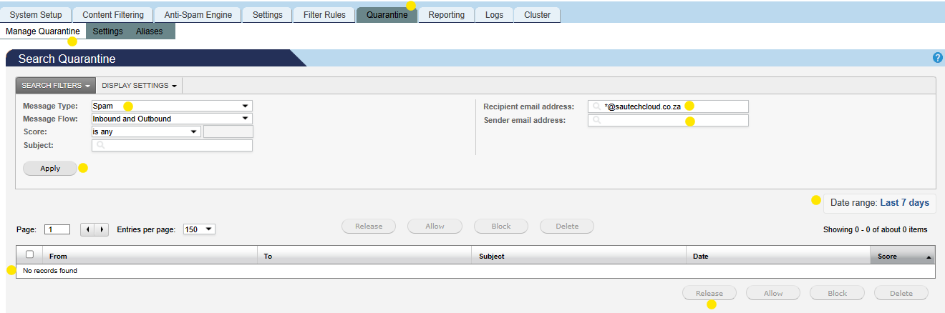

- “Message Type”: Click on “Drop Down” to select “Spam” or “Banned Attachment”:

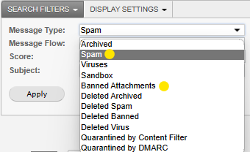

- Track History of all email Sent/Received:

- Click on “Reporting”
- Click on “History”
- Complete either “Recipient” or “Senders” email address
- Select “Date Range”
- Click on “Apply”:

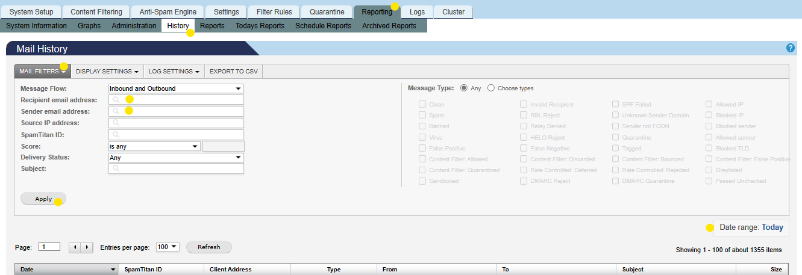

- To Filter Display Settings in History:

- Click on “Display Settings”:
(here you can filter what you would like to see)

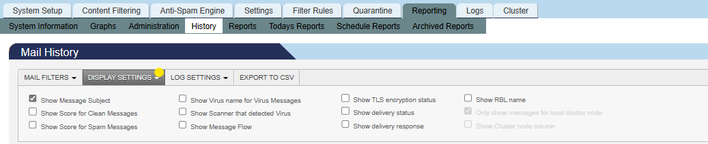

- Daily Report Received:

- User to click on “Deliver” or “Allow”
- “Deliver”: will release the email to the mailbox
- “Allow”: will automatically add the Senders email address to the Whitelist and deliver the email to the mailbox
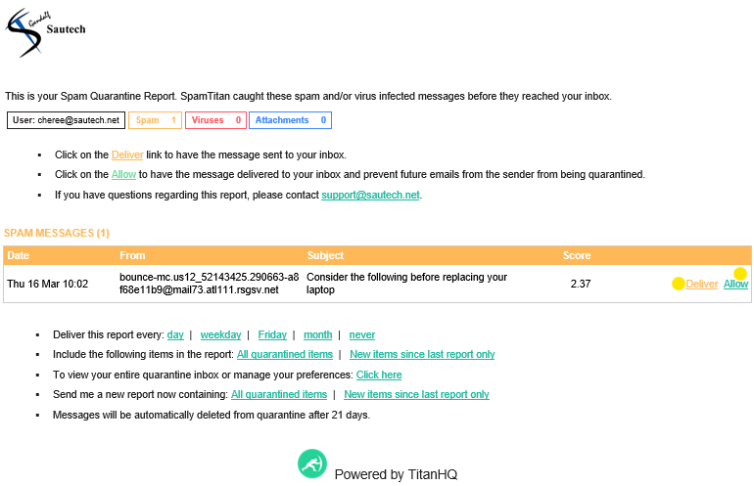
- Users can access any new message that picked up as “Spam” in 2 ways:

Request a “New Report”:
- On the last report that was received, click on “New items since last report only”
- A new report will be sent if any emails were picked up as “Spam”

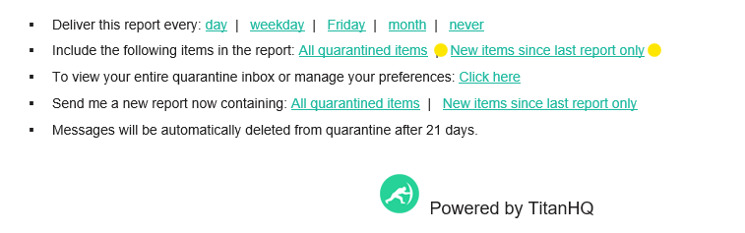

User may log in to “SpamTitan”:
- Obtaining “Password” and “Login”
- In a Web Browser, go to (for example): http://gimli.onlinehosting.co.za
- Click on “Forgot Password” link – enter email address
- Click “Send”:

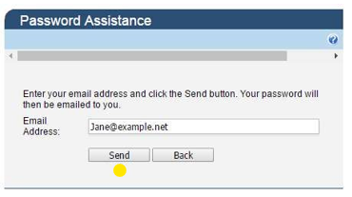

- SpamTitan will send you your “Password” to log in
- Once password is received and user is able to log in:

- Click on “Quarantine” tab
- Select “Message Quarantine”
- Complete either: “Recipient” or “Senders” email address
- Select “Date Range” (on the right)
- Click on “Apply”
- Tick the message that you would like to release
- Click on “Release” (bottom right):

